

ST JOSEPH ENGINEERING COLLEGE, MANGALURU
An Autonomous Institution
Fifth Semester B.E. Degree (Autonomous) Examinations

USN:
22CSE52

Duration: 3 Hrs Maximum Marks: 100

COMPUTER NETWORKS

Note:
- Part-A is mandatory.
- Answer any five full questions from Part-B choosing at least one from each module.
- Missing data may be suitably assumed.
PART-A
Q.No. | Question |  | BL | CO | PO | Marks
1 | Define Computer Networks? |  | L1 | 1 | PO1 | 2
2 | What is FTP? |  | L1 | 1 | PO1 | 2
3 | What is Flooding? |  | L1 | 2 | PO1 | 2
4 | What is Congestion? |  | L1 | 2 | PO1 | 2
5 | What is Tunneling? |  | L1 | 3 | PO1 | 2
6 | What is the role of ICMP in Internet communication, particularly regarding error reporting during packet processing at routers? |  | L1 | 3 | PO2 | 2
7 | Define Multiplexing? |  | L1 | 4 | PO1 | 2
8 | What is Internet daemon? |  | L1 | 4 | PO1 | 2
9 | What is Domain name server? |  | L1 | 5 | PO1 | 2
10 | Explain how does SMTP facilitate the transfer of emails from the originator to the recipient? |  | L1 | 5 | PO2 | 2
 | PART-B
 | Module-1
1 | a) | Explain the uses of computer networks | L2 | 1 | PO1 | 8
1 | b) | Explain the following  - LAN 2. MAN 3. Internetwork | L2 | 1 | PO1 | 8
 | OR
2 | a) | Illustrate the different layers of OSI reference model with suitable diagram | L2 | 1 | PO3 | 8
2 | b) | List and explain the design issues in network software design. | L2 | 1 | PO3 | 8
 | Module-2
3 | a) | Explain the Optimality principle? Solve the following using Dijkstra’s algorithm by finding the shortest path where source node is A and destination node is F  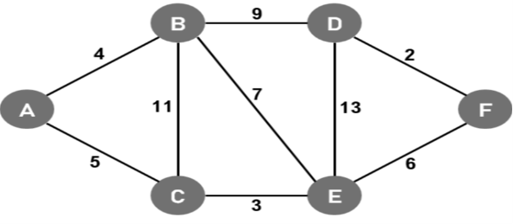 | L3 | 2 | PO5 | 8
3 | b) | Explain the Following  - Load Shedding  - Flooding | L2 | 2 | PO5 | 8
 | OR
4 | a) | Explain steps involved in the Link state algorithm. | L2 | 2 | PO5 | 8
4 | b) | Explain congestion prevention policy in closed loop congestion control | L2 | 2 | PO5 | 8
 | Module-3
5 | a) | Explain in detail the structure of IPV4 with a suitable diagram | L2 | 3 | PO4 | 8
5 | b) | Compare leaky bucket and token bucket in Traffic shaping. | L2 | 3 | PO4 | 8
 | OR
6 | a) | Explain classful addressing with a suitable diagram | L2 | 3 | PO4 | 8
6 | b) | Explain Border Gateway Protocol (BGP). | L2 | 3 | PO4 | 8
 | Module-4
7 | a) | Explain the three-way handshake protocol used for connection establishment and connection release with neat diagrams | L2 | 4 | PO3 | 8
7 | b) | Explain how flow control and error control is achieved at the transport layer | L2 | 4 | PO3 | 8
 | OR
8 | a) | Explain TCP segment header with suitable diagram | L2 | 4 | PO3 | 8
8 | b) | Explain the services provided by the transport layer to the upper layers. | L2 | 4 | PO5 | 8
 | Module-5
9 | a) | Explain the Hyper Text Transfer Protocol. | L2 | 5 | PO6 | 8
9 | b) | Compare POP3 and IMAP. | L4 | 5 | PO6 | 8
 | OR
10 | a) | With a neat diagram explain the parts of the Web model. | L2 | 5 | PO6 | 8
10 | b) | Explain the simple mail transfer protocol. | L4 | 5 | PO6 | 8

